

**Present Simple/Present Continuous**

**Past Simple/Past Continuous**

10. While the lamb ____________, we were eating cheese pie and sausages.

1. cooked c. is cooking
2. was cooking d. cooks
3. School always _______ for Easter holidays.
4. closed c. closes
5. Is closing d. was closing

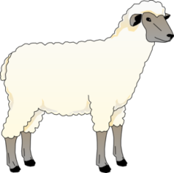

11. My mother and sister ________ salads for the table right now.

a. make c. are making

b. were making d. made

2. This year we ____________ Easter at home.

1. are celebrating c. were celebrating
2. celebrate d. celebrated



12. I ______ up early to help prepared the lamb last year.

1. am getting c. got
2. was getting d. get

3. Last year we _______ the ferry to an island.

1. take c. took
2. are taking d. were taking



4. Every year we ________ lamb on the spit.

a. cooked c. cook

b. are cooking d. was cooking

13. Every Easter all the nearby villages _________ the lamb outdoors.

1. grilled c. grill
2. is grilling d. was grilling



5. The Easter Bunny always ________ us a basket of chocolate eggs.

a. is bringing c. was bringing

b. brought d, brings

14. We _________ on the ferry, when we saw a school of dolphins.

1. travelled c. are travelling
2. travel d. were travelling

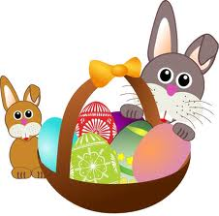

6. We __________ our Easter dinner when it started to rain.

1. ate c. eat
2. were eating d. are eating

15. We ________ at Mykonos three hours ago after a pleasant ferry ride.

a. are arriving c. arrived

b. arrive d. were arriving

7. My grandmother _________ Easter bread but now we buy it from a bakery.

1. bakes c. used to bake
2. is baking d. was baking

16. I ________ about what I wanted to do over Easter vacation, when the Easter Bunny arrived.

1. thought c. think
2. am thinking d. was thinking

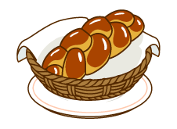



8. At the moment, we _________ Easter eggs red.

1. are dying c. were dying
2. dye d. dyed

17. At the moment we ___________ a walk around a beautiful village.

a. are taking c. were taking

b. take d. took





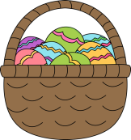

18. When Easter holidays ________, I feel very sad.

a. is ending c. end

b. was ending d. ended

9. We always ______ to church at midnight on Easter Eve every year.

a. went c. are going

b. go d. were going